DBMS ASSIGNMENT – 8

**Functions and Stored Procedures**

***Name: BHAGYA VINOD RANA Roll Number: U19CS012***

Q)Considering the Tables of Assignment 7, create Stored Procedure and Functions as required.

I created the Database in XAMPP & **Imported** the Tables in Apex Oracle Website.

1.) Create a **Function** which returns the seller's name with the highest rating.

Function/Stored Procedure:

-- 1.) Create a Function which returns the seller's name with the highest rating.

CREATE OR REPLACE FUNCTION seller_max_rating RETURN SELLER.SELLER_NAME %TYPE IS ans SELLER.SELLER_NAME %TYPE;

-- Main Execution Part

BEGIN

   SELECT

      SELLER_NAME INTO ans -- SELLER_NAME stored in ans Variable

   FROM

      SELLER

   WHERE

      RATING =

      (

         SELECT

            MAX(RATING)

         FROM

            SELLER

      )

;

-- Return SELLER NAME with Max Rating via ans

RETURN ans;

END;

Test:

-- Declare a Variable 'ans' to Store the Result of Function of Data Type "SELLER.SELLER_NAME"

DECLARE ans SELLER.SELLER_NAME %TYPE;

BEGIN

    ans := seller_max_rating;   -- Function Returns the Name of Seller with highest Rating

    dbms_output.put_line('Seller with Maximum Rating : ' || ans);

END;

Output:

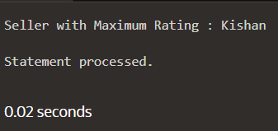 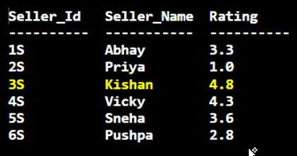

2.) Create **Stored procedure** which takes as an input ‘category’ and outputs all the products of that category.

Function/Stored Procedure:

-- Function that Takes Category and List Down all Products

CREATE OR REPLACE PROCEDURE get_all_products (category_input IN CATEGORY.CATEGORY %TYPE) IS c_prod product.product %TYPE;

-- CURSOR -> To Retrieve Data [1 Row at a Time]

CURSOR c_product IS

SELECT

   PRODUCT

FROM

   PRODUCT

WHERE

   CATEGORY_ID =

   (

      SELECT

         CATEGORY_ID

      FROM

         CATEGORY

      WHERE

         CATEGORY = category_input

   )

;

BEGIN

OPEN c_product;

    -- Loop that will Print All Products of that Category

    LOOP FETCH c_product INTO c_prod;

    EXIT WHEN

    c_product % notfound;

    dbms_output.put_line(c_prod);

    END

    LOOP;

CLOSE c_product;

END;

Test:

BEGIN

   get_all_products('Home Decor');

END;

Output:

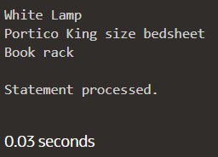 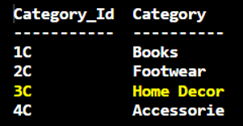

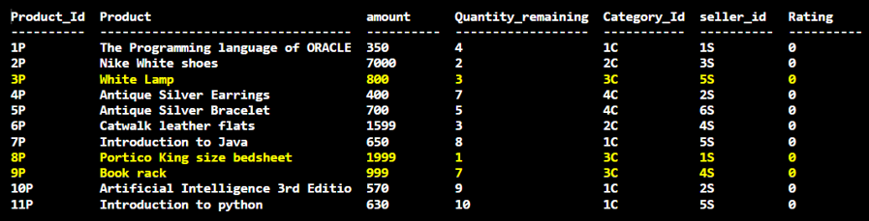

3.) Create **Stored procedure** to take a range of prices as input and output all the products in the provided range.

Function/Stored Procedure:

-- Take Input Two Parameters [low & high] and Display all Product within that Range

CREATE OR REPLACE PROCEDURE prod_in_range(low_lmt IN PRODUCT.AMOUNT %TYPE, up_lmt IN PRODUCT.AMOUNT %TYPE) IS c_prod product.product %TYPE;

-- Retrieve Data [1 Row at a Time]

CURSOR c_product IS

SELECT

  PRODUCT

FROM

  PRODUCT

WHERE

  AMOUNT BETWEEN low_lmt AND up_lmt;

BEGIN

OPEN c_product;

  LOOP FETCH c_product INTO c_prod;

    EXIT WHEN

    c_product %notfound;

    dbms_output.put_line(c_prod);

  END LOOP;

CLOSE c_product;

END;

Test:

-- Function CALL to Stored Procedure

BEGIN

    prod_in_range(550,1700);

END;

Output:

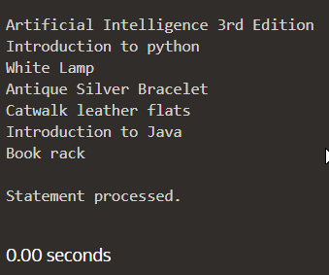

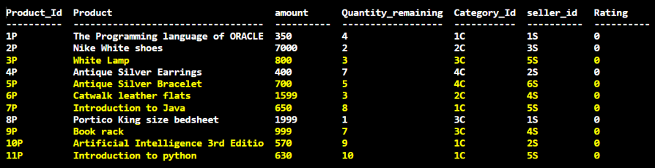

4.) Create **Function** to display all the seller details with rating more than 3.

Function/Stored Procedure:

- returning a sys_refcursor you allow the client to fetch as many or few of the rows from the query as it requires [STACKOVERFLOW]

CREATE OR REPLACE FUNCTION get_good_rated_sellers RETURN SYS_REFCURSOR IS s_details SYS_REFCURSOR;

BEGIN

OPEN s_details FOR

  SELECT DISTINCT   --Avoid Duplicate Entries

    SELLER_ID,

    SELLER_NAME,

    RATING

  FROM

    SELLER

  WHERE

    RATING > 3;

RETURN s_details;

END;

Test:

-- Declare all Necessary Variables

DECLARE s_details SYS_REFCURSOR;

s_id SELLER.SELLER_ID %type;

s_name SELLER.SELLER_name %type;

s_rating SELLER.rating %type;

BEGIN

    s_details := get_good_rated_sellers;

    dbms_output.put_line('  SELLER_ID   |   SELLER_NAME |   SELLER_RATING   ');

    -- Loop to Display the Output

    LOOP FETCH s_details INTO s_id, s_name, s_rating;

    EXIT WHEN s_details % NOTFOUND;

    dbms_output.put_line(s_id || '  ' || s_name || '  ' || s_rating);

    END LOOP;

END;

Output:

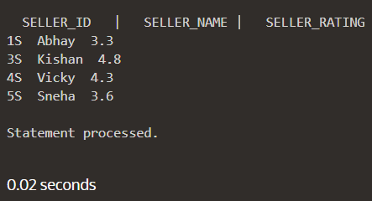 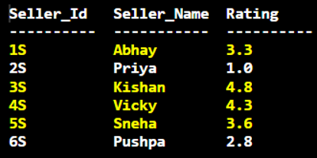

5.) Create a **Function** to display all the products, seller wise.

Function/Stored Procedure:

-- fetch as many or few of the rows from the query as it requires = SYS_REFCURSOR

CREATE OR REPLACE FUNCTION display_products_seller_wise RETURN SYS_REFCURSOR IS prods SYS_REFCURSOR;

BEGIN

    OPEN prods FOR

    SELECT PRODUCT, SELLER_ID

    FROM PRODUCT SELLER

    ORDER BY SELLER_ID;

    RETURN prods;

END;

Test:

-- Declare all Necessary Variables

DECLARE details SYS_REFCURSOR;

p_name SELLER.SELLER_name %type;

s_id SELLER.SELLER_ID %type;

BEGIN

    details := display_products_seller_wise;

    dbms_output.put_line('S_ID | PRODUCT_NAME ');

    -- Loop to Display the Output

    LOOP FETCH details INTO p_name,s_id;

    EXIT WHEN details%NOTFOUND;

    dbms_output.put_line(s_id || ' ' || p_name);

    END LOOP;

END;

Output: [Seller-Wise Product List]

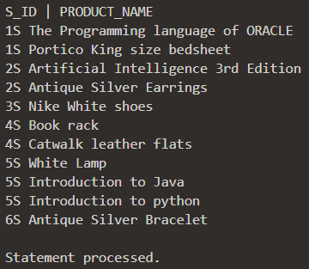

6.) Create a **Stored procedure** which checks all the entries in Order_Products table and update seller and product table accordingly.

Function/Stored Procedure:

CREATE OR REPLACE PROCEDURE update_product_seller_tables AS

BEGIN

    UPDATE

        product p

    SET

        p.rating = (

         SELECT AVG(prod_rating)

         FROM order_product

         GROUP BY product_id

         HAVING product_id = p.product_id

        );

    UPDATE

        seller s

    SET

        s.rating = (

        SELECT AVG(prod_rating)

        FROM order_product

        GROUP BY seller_id

        HAVING seller_id = s.seller_id

        );

END;

Test:

-- Function CALL to Stored Procedure

BEGIN

    update_product_seller_tables;

END;

Output:

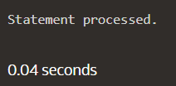

7.) Create **Stored procedure** which takes as input different filters such as price range, category, product rating, seller rating, out of stock and displays the list of products with all the details after applying filters

Function/Stored Procedure:

CREATE OR REPLACE PROCEDURE filter_criteria(OPT IN NUMBER, FILTERING_LIMIT IN varchar) IS prod_details SYS_REFCURSOR;

prod_prodid PRODUCT.PRODUCT_ID %type;

prod_name PRODUCT.PRODUCT %type;

prod_amt PRODUCT.AMOUNT %type;

prod_quant PRODUCT.QUANTITY_REM %type;

prod_catid PRODUCT.CATEGORY_ID %type;

prod_sellerid PRODUCT.SELLER_ID %type;

prod_rating PRODUCT.RATING %type;

BEGIN

-- Switch Case : [1 -> amount | 2 -> category | 3 -> product-rating | 4 -> seller-rating | 5 -> checking in stock]

CASE opt

    -- AMOUNT FILTER

    WHEN 1 THEN

         OPEN prod_details FOR

         SELECT

            PRODUCT_ID, PRODUCT, AMOUNT, QUANTITY_REM, CATEGORY_ID, SELLER_ID, RATING

         FROM

            PRODUCT

         WHERE

            AMOUNT < TO_NUMBER(FILTERING_LIMIT);

    -- CATEGORY FILTER

    WHEN 2 THEN

        OPEN prod_details FOR

        SELECT

            PRODUCT_ID, PRODUCT, AMOUNT, QUANTITY_REM, CATEGORY_ID, SELLER_ID, RATING

        FROM

            PRODUCT

        WHERE

            CATEGORY_ID = FILTERING_LIMIT;

    -- PRODUCT RATING FILTER

    WHEN 3 THEN

        OPEN prod_details FOR

        SELECT

            PRODUCT_ID, PRODUCT, AMOUNT, QUANTITY_REM, CATEGORY_ID, SELLER_ID, RATING

        FROM

            PRODUCT

        WHERE

            RATING >= TO_NUMBER(FILTERING_LIMIT);

    -- SELLER RATING FILTER

    WHEN 4 THEN

        OPEN prod_details FOR

        SELECT

            PRODUCT_ID, PRODUCT, AMOUNT, QUANTITY_REM, CATEGORY_ID, SELLER_ID, RATING

        FROM

            PRODUCT

        WHERE

        SELLER_ID IN (

         SELECT

            SELLER_ID

         FROM

            SELLER

         WHERE

            RATING >= TO_NUMBER(FILTERING_LIMIT)

        );

    -- CHECKING IN STOCK FILTER

    WHEN 5 THEN

        OPEN prod_details FOR

        SELECT

            PRODUCT_ID, PRODUCT, AMOUNT, QUANTITY_REM, CATEGORY_ID, SELLER_ID, RATING

        FROM

            PRODUCT

        WHERE

            QUANTITY_REM <> 0;

END CASE;

-- Loop to Print Output

    LOOP FETCH prod_details INTO prod_prodid, prod_name, prod_amt, prod_quant, prod_catid, prod_sellerid, prod_rating;

    EXIT WHEN prod_details%NOTFOUND;

    dbms_output.put_line( prod_prodid || ' ' || prod_name || ' ' || prod_amt || ' ' || prod_quant || ' ' || prod_catid || ' ' || prod_sellerid || ' ' || prod_rating);

    END LOOP;

END;

Test & Output:

-- Sorting Criteria :

[1 -> amount | 2 -> category | 3 -> product-rating | 4 -> seller-rating | 5 -> checking in stock]|[filtering limit]

BEGIN

    dbms_output.put_line( 'P_ID' || ' | ' || 'PRODUCT' || ' | ' || 'AMOUNT' || ' | ' || 'QUANTITY' || ' | ' || 'CAT_ID' || ' | ' || 'SELLER_ID' || ' | ' || 'RATING');

    -- AMOUNT < 1000

    filter_criteria(1, 1000);

    -- CATEGORY "1C"

    filter_criteria(2, '1C');

    -- PRODUCT RATING >3

    filter_criteria(3, 3);

    -- SELLER RATING >4

    filter_criteria(4, 4);

    -- STOCK AVAILABLE (2 nd Paramater Does Not Matter)

    filter_criteria(5, 3);

END;

(A) Filter by **Amount**

filter_criteria(1, 1000);

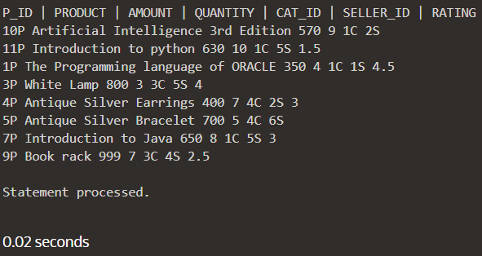

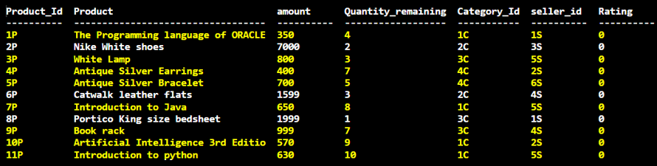

(B) Filter by **Category**

filter_criteria(2, '1C');

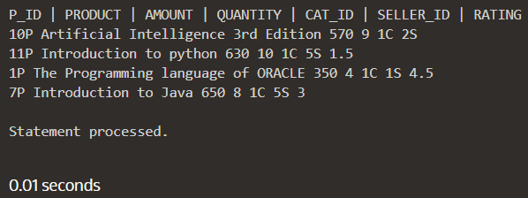

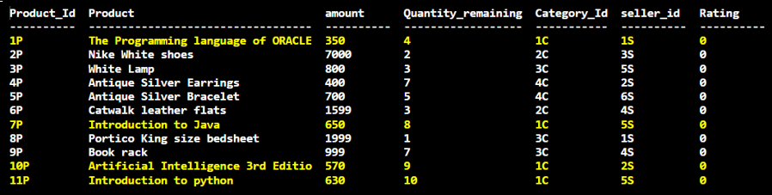

(C) Filter by **Product Rating**

filter_criteria(3, 3);

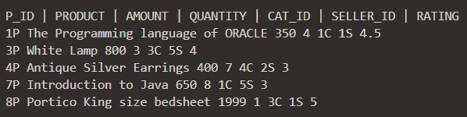

(D) Filter by **Seller Rating**

    filter_criteria(4, 4);

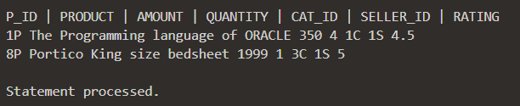

(E) Filter by Stock Available

-- STOCK AVAILABLE (2 nd Paramater Does Not Matter)

    filter_criteria(5, 3);

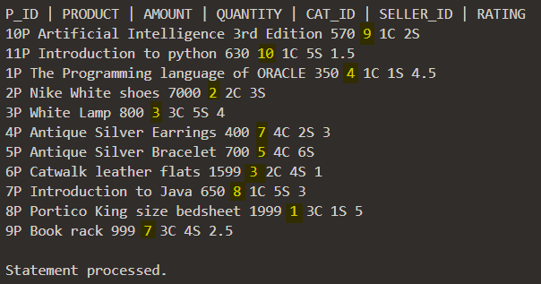

8.) Create a **Function** which takes as input sorting criteria like popularity or lowest price or highest price and display the product list accordingly.

Function/Stored Procedure:

CREATE OR REPLACE FUNCTION sort_criteria(opt IN number) RETURN SYS_REFCURSOR IS prod_details SYS_REFCURSOR;

    BEGIN CASE opt

        -- 1 : Price Lowest to Highest

        WHEN 1 THEN

            OPEN prod_details FOR

            SELECT

                PRODUCT_ID, PRODUCT, AMOUNT, QUANTITY_REM, CATEGORY_ID, SELLER_ID, RATING

            FROM

                PRODUCT

            ORDER BY

                AMOUNT;     -- By Default Ascending

        -- 2 : Price Highest to Lowest

        WHEN 2 THEN

            OPEN prod_details FOR

            SELECT

                PRODUCT_ID, PRODUCT, AMOUNT, QUANTITY_REM, CATEGORY_ID, SELLER_ID, RATING

            FROM

                PRODUCT

            ORDER BY

                AMOUNT DESC;

        -- 3 : Rating Lowest to Highest

        WHEN 3 THEN

            OPEN prod_details FOR

            SELECT

                PRODUCT_ID, PRODUCT, AMOUNT, QUANTITY_REM, CATEGORY_ID, SELLER_ID, RATING

            FROM

                PRODUCT

            ORDER BY

                RATING;     -- By Default Ascending

        -- 4 : Rating Highest to Lowest

        WHEN 4 THEN

            OPEN prod_details FOR

            SELECT

                PRODUCT_ID, PRODUCT, AMOUNT, QUANTITY_REM, CATEGORY_ID, SELLER_ID, RATING

            FROM

                PRODUCT

            ORDER BY

                RATING DESC;

   END CASE;

RETURN prod_details;

END;

Test & Output:

-- Declare all Necessary Variables

DECLARE prod_details SYS_REFCURSOR;

prod_prodid PRODUCT.PRODUCT_ID % type;

prod_name PRODUCT.PRODUCT % type;

prod_amt PRODUCT.AMOUNT % type;

prod_quant PRODUCT.QUANTITY_REM % type;

prod_catid PRODUCT.CATEGORY_ID % type;

prod_sellerid PRODUCT.SELLER_ID % type;

prod_rating PRODUCT.RATING % type;

BEGIN

    dbms_output.put_line( 'P_ID' || ' | ' || 'PRODUCT' || ' | ' || 'AMOUNT' || ' | ' || 'QUANTITY' || ' | ' || 'CAT_ID' || ' | ' || 'SELLER_ID' || ' | ' || 'RATING');

    -- 1 : Price Lowest to Highest

    prod_details := sort_criteria(1);

    -- 2 : Price Highest to Lowest

    prod_details := sort_criteria(2);

    -- 3 : Rating Lowest to Highest

    prod_details := sort_criteria(3);

    -- 4 : Rating Highest to Lowest

    prod_details := sort_criteria(4);

    -- Loop to Print the Output

    LOOP FETCH prod_details INTO prod_prodid, prod_name, prod_amt, prod_quant, prod_catid, prod_sellerid, prod_rating;

    EXIT WHEN prod_details%NOTFOUND;

    dbms_output.put_line( prod_prodid || ' ' || prod_name || ' ' || prod_amt || ' ' || prod_quant || ' ' || prod_catid || ' ' || prod_sellerid || ' ' || prod_rating);

    END LOOP;

END;

(A) Sort by Price [Lowest to Highest]

    prod_details := sort_criteria(1);

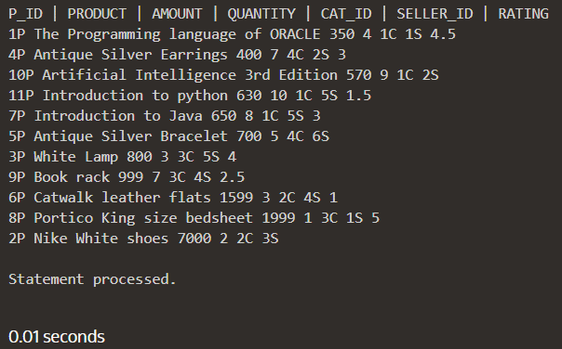

(B) Sort by Price [Highest to Lowest]

    prod_details := sort_criteria(2);

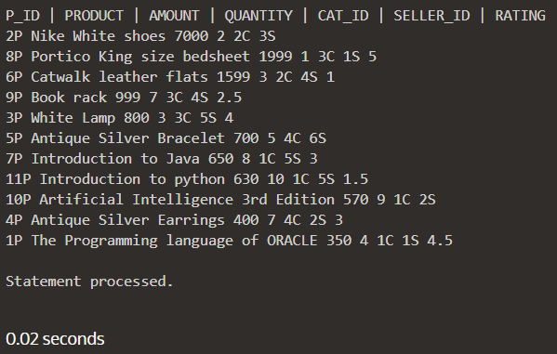

(C) Sort by Rating [Lowest to Highest]

    prod_details := sort_criteria(3);

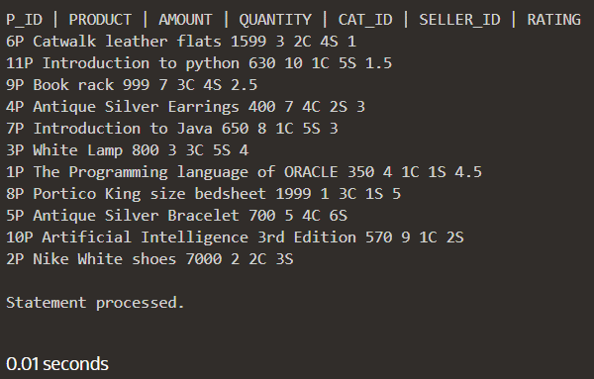

(D) Sort by Rating [Highest to Lowest]

    prod_details := sort_criteria(4);

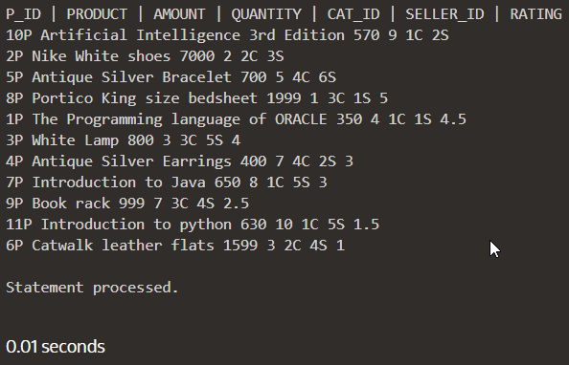

**Submitted By:**

**BHAGYA VINOD RANA**

**U19CS012**